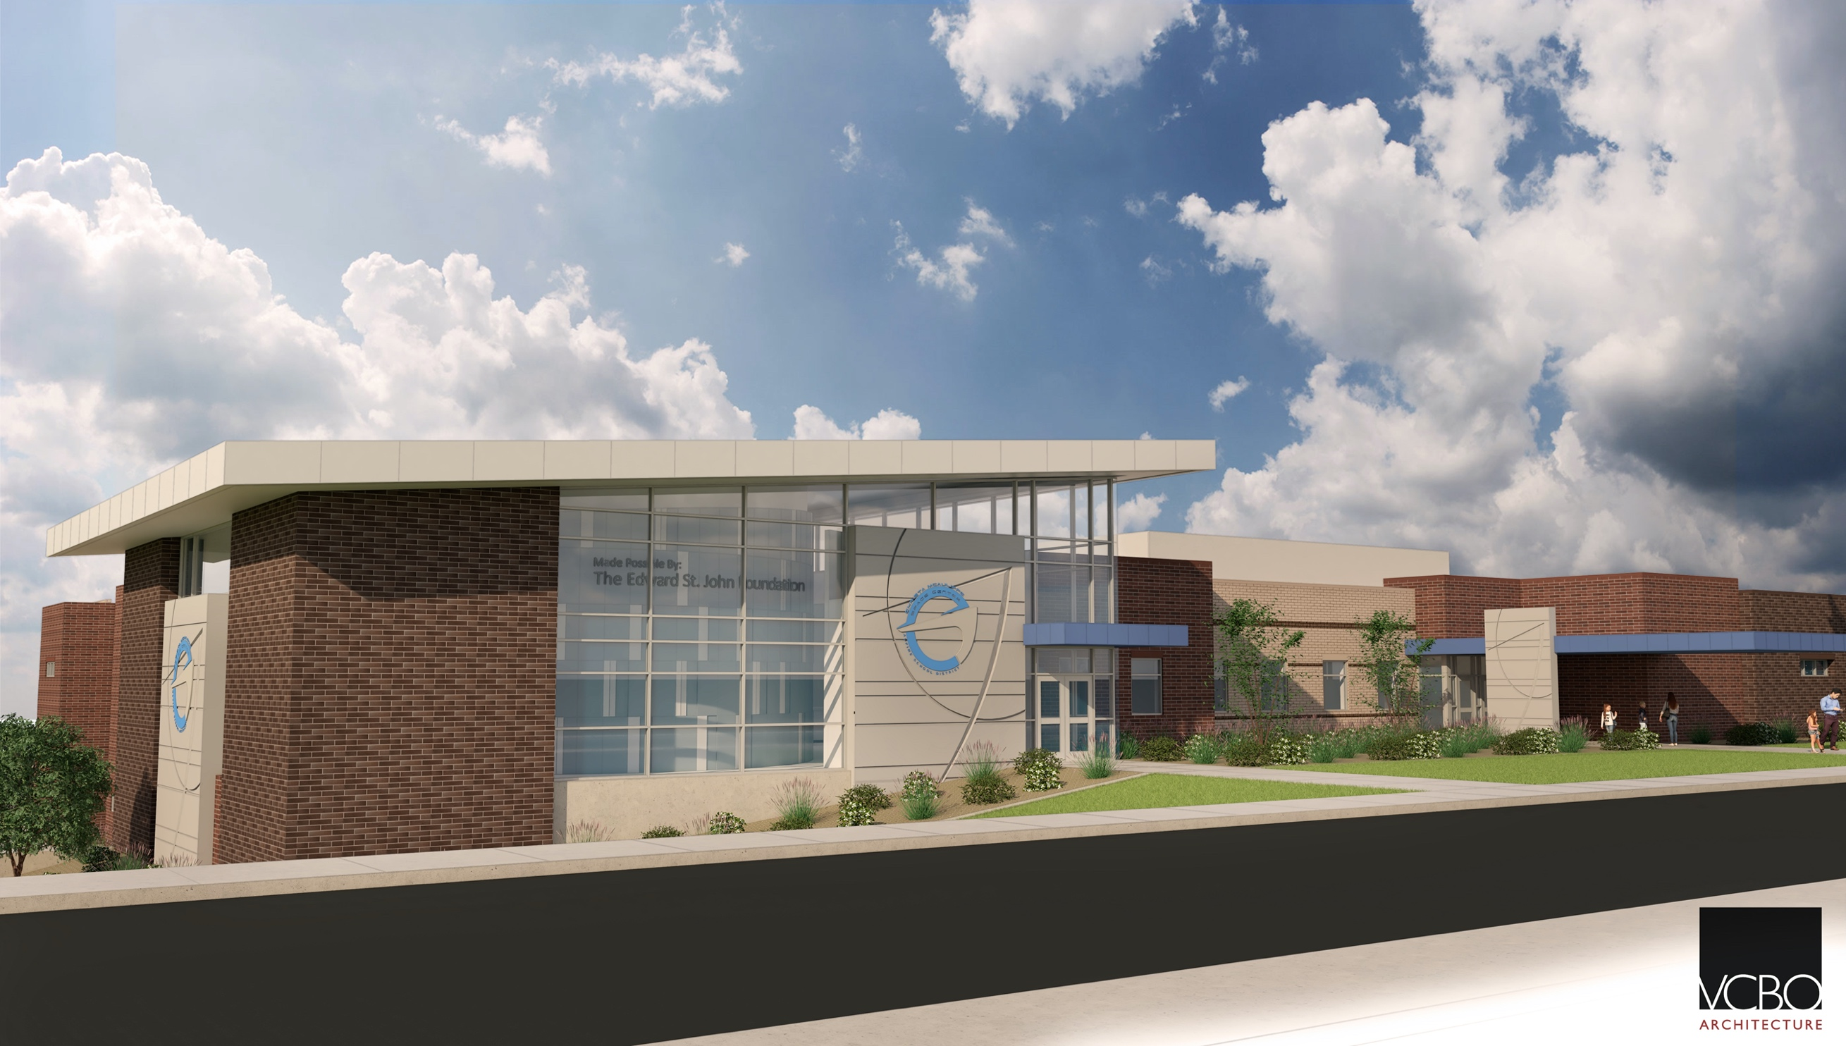

**Principal** – Ryan Wells

**Secretaries** – Kathy Lee & Gay Armitstead

**Custodian** – Brandon Pace

**Preschool** – Camille Davis

**Kindergarten** – Nonie Hunter & Kirsten Richins

**1st Grade** –Natalie Mack, Sonia Berghoff, & Jessica Harter

**2nd Grade** – Bethany Jones, Chelsea Larsen, & Kay Bratt

**3rd Grade** – Talese Baxter, Stephanie Bate & Lonni Call

**4th Grade** – Carol Winkleman, & Jenny Wood

**5th Grade** – Natalie Nuttall, & Christina Walker

**6th Grade** –Kayla Broome, Arline Johnson, & Brooke Anderson

**Special Ed.** – Joann Kirk

**Computers** – Belinda Haderlie

**PE –** Ashli Houston

**Music –** Stephanie Larson

**Media** – Suzanne Christofferson

**School Psych.** – Janine Blaisdell

**Speech** – Paula Malone

**Coach –** Amy Wanner & Bethany Hancock

**School Counselor –** Janna Wiltbank

**Mission Statement**

All Central Tigers are fierce about learning and we are Central Tigers.

**Vision**

We will create a positive and nurturing learning community that strives for high achievement by focusing on academics, behavior, and attendance.

Central Elementary

Stakeholder Report

2020 - 2021

# Staff List

95 North 400 East

Pleasant Grove, UT 84062

801-610-8104

http://central.alpineschools.org

##### **PTA Executive Board**

President

Chanel Eral

President-Elect

Vacant

Secretary

Emily Fullmer

Treasurer

Ann Porter

##### **School Community Council**

Chairperson

Erin Brown

Parent Members

### **Lindsey Chavira**

### Ann Porter

### Melanie Tucker

### Jocelyn Blackhurst

Staff Members

Ryan Wells

Natalie Nuttall

Sonia Berghoff

The Utah State Office of Education   
recently released the state core   
testing for the 2020 – 2021 school   
year. We will use this data to   
identify instructional needs and   
work to steadily increase our   
proficiency scores on all tests.   
Central continues to perform well   
for our demographics. We are   
pleased with this progress and we   
appreciate the efforts of teachers,   
students, and parents in helping to   
attain this achievement.

Our success at Central is due, in large part, to parent support. We are grateful for the many parent volunteers who help students on a daily basis. Involvement at home is undoubtedly the most important kind of parent involvement. We appreciate the support parents give by talking to their children about school, providing a quiet place to do homework, and teaching them respect for others and responsibility for their own behavior. We also appreciate your support of Parent/Teacher conferences, the Christmas Sing, Art Nights, the Dance Festival, Read Around the World, the School Play, PTA activities, Grade Level and Classroom programs, and all other activities available at Central.

Finally, we appreciate the opportunity to be the home of the Christa McAulliffe Space Education Center. The Space Center staff provides many opportunities for learning and growth for our students. It is a great partnership.

Our School Community Council is in charge of approving our School LAND Trust Plan and accompanying budget. Central received $66,478 in LAND Trust money.

To encourage early childhood reading, School LAND Trust money went towards hiring an aide to run the You, Me, and a Book Program. This initiative allows all students K-2 to bring home books on their level. Money was also used to purchase more books for this program, the library, and for Battle of the Books.

Classroom aides assist in the classroom and help intervene for at risk groups of students.

School LAND Trust money help pay for teachers to meet over the summer to plan and collaborate for the upcoming year. This ensures that teachers hit the ground running when school starts.

Central also invests this money in teacher supplies and teaching materials.  Money goes towards paying for subs to allow for further team collaboration time and teacher training.

Thank you for your continued support of Central Elementary.

The Utah State Office of Education recently released the state core testing for the 2014 – 2015 school year. We will use this data to identify instructional needs and work to steadily increase our proficiency scores on all tests. We were designated a USOE Title I Reward School for 2015. We are pleased with this honor and we appreciate the efforts of teachers, students and parents in helping to attain this achievement.

We are continually striving to improve our instructional strategies to meet the needs of each student. Targeted students at every grade level have been invited to participate in a double-dose session with a certified teacher to help them increase proficiency in reading and/or math. We encourage you to have your students participate in double dose when invited and if you have any questions, please contact the office at 801-610-8104. On Monday collaboration days, teacher teams align instruction with the Utah State Core Curriculum, develop assessments, evaluate individual student’s test data, and develop remediation plans for targeted areas of need. The staff at Central continually works together to provide the best educational experience for each of your students.

Our success at Central is due, in large part, to parent support. We are grateful for the many parent volunteers who help students on a daily basis. Involvement at home is undoubtedly the most important kind of parent involvement. We appreciate the support parents give by talking to their children about school, providing a quiet place to do homework, and teaching them respect for others and responsibility for their own behavior. We also appreciate your support of Parent/Teacher conferences, the Christmas Sing, Art Nights, the Dance Festival, Battle of the Books, the School Play, PTA activities, Grade Level and Classroom programs, and all other activities available at Central.

Finally, we appreciate the opportunity to be the home of the Christa McAulliffe Space Education Center. The Space Center staff provides many opportunities for learning and growth for our students. It is a great partnership.

Thank you for your continued support of Central Elementary.

# LAND Trust Report